**GAM150 - Production Report Week 11**

# Report Summary:

* **Week 11**
* **3/30/17**
* **By Cole Astaire**

# Summary:

**Game Name: Blast Droids**

**High Concept:**

* **Traverse countless deadly star systems with your friends using a cast of unique ships.**

# Team Roster:

* **Team Name: TeamA001**
* **Team ID: A01**

|  |  |  |
| --- | --- | --- |
| **Name (printed or typed)** | **Role** | **Signature** |
| **Cole Astaire** | **Producer** |  |
| **Evan Kau** | **Systems Programmer,**  **Design Director** |  |
| **Ryan Booth** | **Product Manager,**  **Operations Assistant** |  |
| **Henry Brobeck** | **Technical Director** |  |
| **Israel Zevenbergen** | **Test Manager** |  |

# Project Summary:

## Next Milestone:

* Clarity Rush 2 – Preparation for beta, Polish
  + Begins 3/27/17
  + Ends 4/4/17
* Beta Preparation
  + Begins 4/3/17

## Project Status Towards Milestone: yellow

## Progress Against Last Week’s Objectives:

* Ryan
  + Text rendering for use in floating combat text components
    - Currently in development
* Cole
  + Playtest Report
  + Text Rendering for use in floating combat text components
    - Currently in development
* Hank
  + Finished 2 abilities of player ship (Missile-Boy). Added cooldown bars under player ships. Added corner HUD Health Bars prototype.
* Evan
  + Completed asset hashmap.
  + Added suicide enemy.
* Israel
  + Continue work on improved particle implementation.

**Next Weeks’ Objectives:**

* **Ryan**
  + **Finalizing floating text**
  + **Menu Overhaul**
    - **PNG’s to Mesh Menus**
* **Cole**
  + **Menu Overhaul**
  + **Audio Library**
    - **One sound for each action**
* **Hank**
  + **Finish player ship and fix warning and errors**
* **Evan**
  + **Jumpgate blocker.**
  + **Ramping difficulty.**
  + **Work on Bulwark.**
* **Israel**
  + **Particle effects update, enable particle effects for all actions**

**Additional Accomplishments:**

* Outlined plan for beta and finalized product.
  + Utilized a method Evan learned from upper-classmen
* 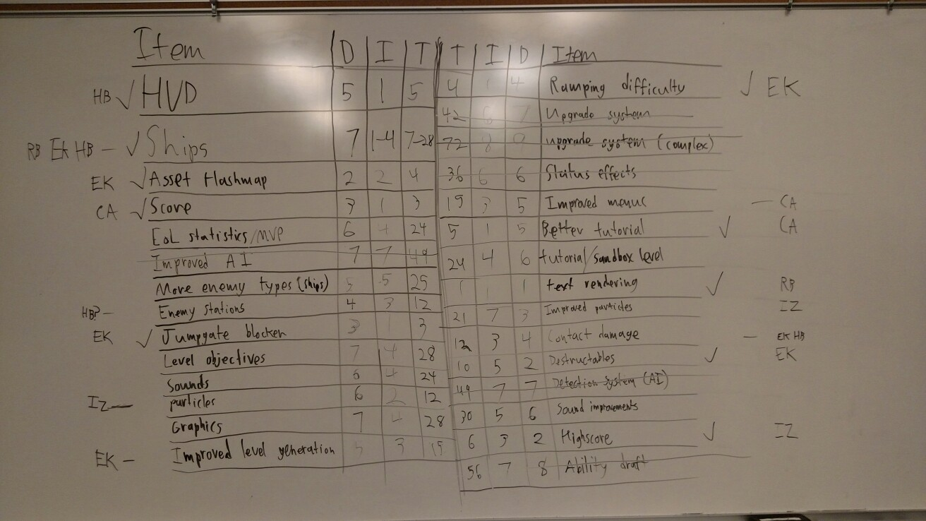

## Lowlights:

* Team-wide motivation loss. Need rally.

**Risks & Mitigations:**

* Art
  + Committed to vector graphics
    - particle system implemented to improve visual fidelity.
* Procedural Generation
  + Time consuming, engine intensive, but provides replayability.
    - Compare time spent designing individual maps vs. time spent optimizing procedural generation.
* AI
  + Design around simple, scalable AI
* Data Tracking/Logging
  + Infinitely complex. Determining valuable data takes time and effort.
    - Create tracking tools that can track a variety of data sets.
* Engine Spaghetti
  + Component-based Architecture foreign to some team members.
    - Technical Director assuming responsibility for team understanding.
* Sound and immersion
  + Using Bfxr, a third-party sound generator.